1. Add a column (Postal Code) to the Customer table and add some records to the column.



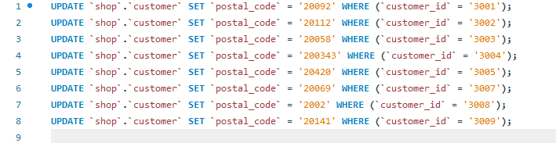

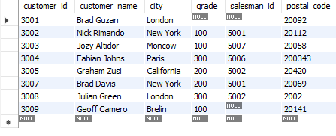

1. Retrieve salesman id of all salesmen from orders table without any repeats.



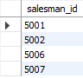

1. Display names and city of salesman, who belongs to the city of Paris.





1. Display all the information for those customers with a grade of 200



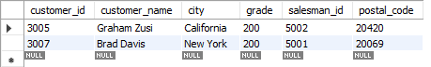

1. Display the order number, order date and the purchase amount for order(s) which will be delivered by the salesman with ID 5001



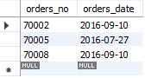

9) Display all the customers, who either belongs to the city New York or not had a grade above 100.





10) Find those salesmen with all information who gets the commission within a range of 0.10 and 0.12.



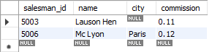

11) Find the total purchase amount of all orders





12) Find the number of salesman currently listing for all of their customers





13)Find the highest grade for each of the cities of the customers



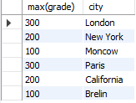

14) Find the highest purchase amount ordered by each customer with their ID and highest purchase amount



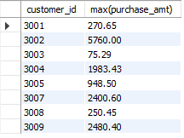

15) Find the highest purchase amount ordered by each customer on a particular date with

their ID, order date and highest purchase amount.



